SAMPLE OUTPUTS:
- Input video file : shuttle.avi (input video MATLAB)
Enter number of frames to process (max: 121): 27
Video saved as "combined_denoised_output.avi"
====== Kalman vs Original (Input Video) Metrics ======
Average PSNR : 33.8487 dB
Average SSIM : 0.9511
Average MSE : 0.000590
======================================================
====== Wiener vs Original (Input Video) Metrics ======
Average PSNR : 22.5983 dB
Average SSIM : 0.5759
Average MSE : 0.005498
======================================================

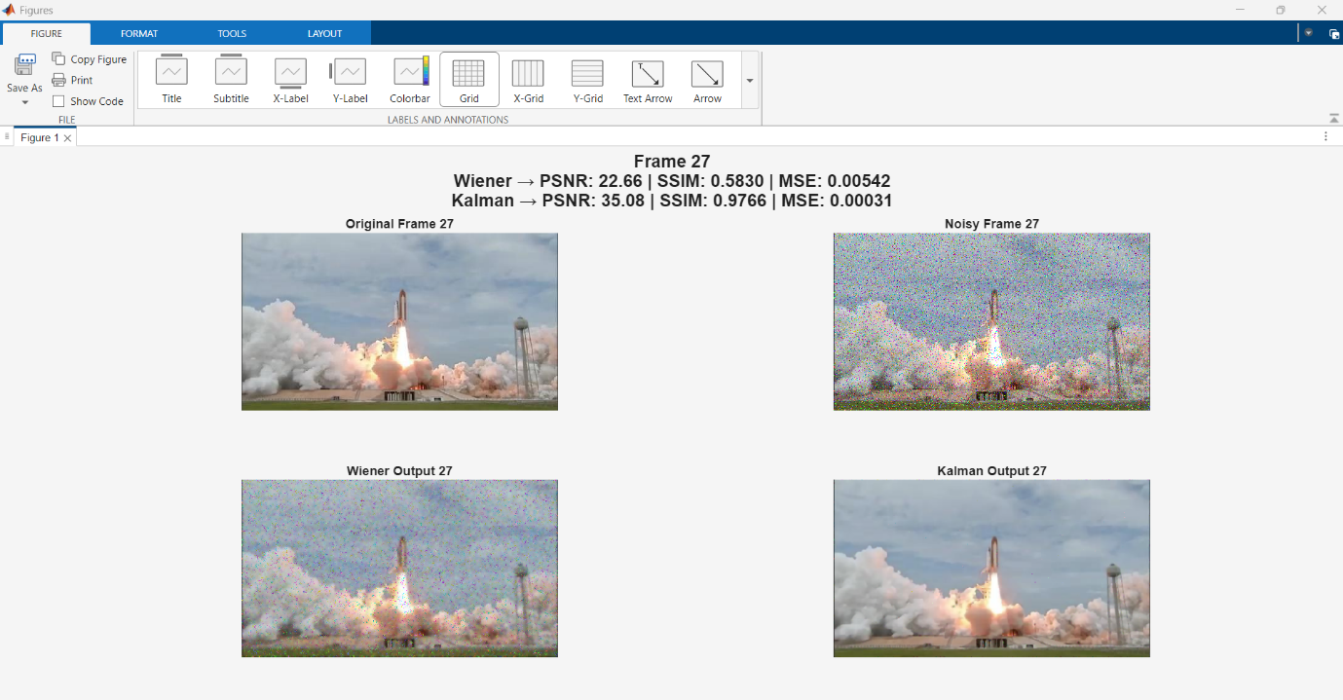

- Input video file: moon.avi
The input video of moon.avi I have attached below.

Enter number of frames to process (max: 901): 27
Video saved as "combined_denoised_output.avi"
====== Kalman vs Original (Input Video) Metrics ======
Average PSNR : 36.9670 dB
Average SSIM : 0.8993
Average MSE : 0.000693
======================================================
====== Wiener vs Original (Input Video) Metrics ======
Average PSNR : 19.3897 dB
Average SSIM : 0.1651
Average MSE : 0.011509
======================================================
>>

